Just Plain Data Analysis: Using Social Indicator Data to Make Sound Policy

Instructor:
Gary M. Klass, Ph.D., Associate Professor
Department of Politics and Government
Illinois State University

Saturday, October 24, 9:00 a.m. - 11:30 a.m.
Seminar Description: This seminar addresses three practical skills: finding the good data, effectively presenting those data, and making sound interpretations. Good data presentation skills are to data-based analysis what good writing is to literature, and some of the same principles apply to both. Poor tabular and graphical presentations often obscure critical facts and lead both readers and writers to draw erroneous conclusions from their data. Data interpretation entails drawing valid conclusions from numerical comparisons and recognizing and avoiding common statistical fallacies in data-based arguments. The seminar will also address how some statistical agencies hide data in plain sight, provide examples of bad graphical design from criminal justice research, and offer tips on using the Excel 2007 charting software.

Justice Plain Data Analysis website:
http://lilt.ilstu.edu/jpda/

Seminar materials (Powerpoint and Excel files):
http://lilt.ilstu.edu/jpda/JRSA

Part I: Data Presentation
Principles of Data Display
General Principles (Tufte):
- “well-designed presentation of data of substance, statistics and design
- “complex ideas communicated with clarity, precision and efficiency
- “the greatest number of ideas in the shortest time with the least ink in the smallest space.
Also:
- Tables (and charts) should be self-explanatory.
- There is no reason why the font in a chart or table should be larger than that used in the text.
- Use titles, headings, notes and legends to precisely (but efficiently) define what each datapoint means.
Tabular Display:
- Sort data on the most meaningful variable, never sort a table alphabetically.
- Round numbers off to two or three significant digits and to thousands or millions as is appropriate. No correlation coefficient needs three decimal places.
- Better if variables go down the columns rather than across the rows.
- Time goes left to right across the column headings. Top to bottom down the rows.
- Horizontal lines, yes; Vertical lines, no.
Graphical Display: General
- Show the data!
- Minimize the ink to data ratio
    - Avoid ChartJunk
    - Never use 3-D displays
    - Minimize gridlines
    - Eliminate chart and plot-area borders
- Sort the data on the most significant variable.
- Avoid data distortion.
- Multivariate displays are better than univariate displays.
- Highlight comparisons; Avoid comparing data across two different charts.
- Four or five axis tick mark labels are enough.
Pie Charts
- Don’t use them!
- Only use pie charts for numbers that add up to a meaningful total.
- Two Pie Charts are worse than one.
- Two 3-D Pie Charts are even worse.
- Cone, pyramid, radar and donut charts are worse than useless.

Bar Charts
- Minimize legend space: place legends (if necessary) horizontally above, below or inside the plot area.
- It is usually best to arrange the data series so that years are within group categories:
- Note: Excel allows for the X-axis as shown above, eliminating the need for a legend and different colors and shading for the data series.
- Use different shades before using different colors. Do not use borders on the bars.
- With stacked bars, the most important category goes at the bottom.
- With time series, bars (or, area charts) can be used to represent volumes or aggregate totals; rates and averages are best displayed with lines.
- Dot plots use less ink than bar charts.
Time series (line) charts
- Consider placing the Y-axis on the right, the last datapoint is usually the most important.
- Label the lines rather than using legends.
- Avoid the use of different datapoint markers to distinguish lines. Lines that do not overlap do not need unique colors, shades or markers.
- Beware of scaling distortion.
Scatterplots
- Always have the dependent variable on the Y-axis.
- Maximize the plot area by adjusting the axes.
- Whenever possible, label the datapoints rather than just using dots.

Cross-sectional time-series bar chart
- Each year is a data series
- Numbers are data-labels* for the 2001 data series (using a chart-labeller)

Sparklines:
“"intense, simple, wordlike graphics"
- Tufte
Bar-chart sparklines:
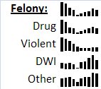

Bubble-scatterplot with chart labelling:
Violent Crime and Arrest Rate: New York Counties, 2007

Examples of Excellent Data Display
Defense presentation at John Gotti trial:

This Chart is described in Tufte, Envisioning Information, p. 31.
Reconstructed by Christy Zlatos, http://hdl.handle.net/2376/1976

The British "Breathalyser" Crackdown:
H. Laurence Ross, Donald T Campbell, Gene V Glass. “Determining the Social Effects of a Legal Reform; The British "Breathalyser" Crackdown of 1967,” The American Behavioral Scientist, /Apr 1970. Vol. 13, Iss. 4; p. 501

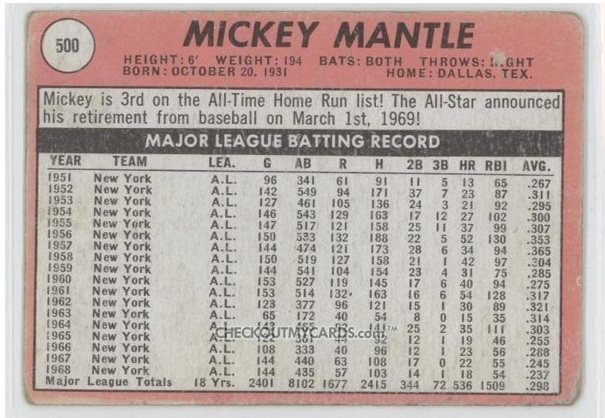

Really Bad Charts
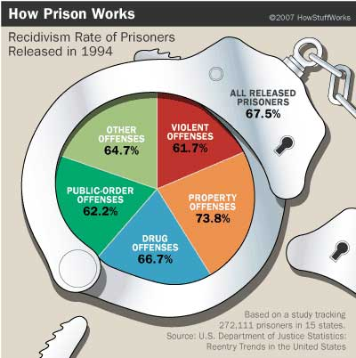 |  | Joel Best rates this as the worst pie chart ever.
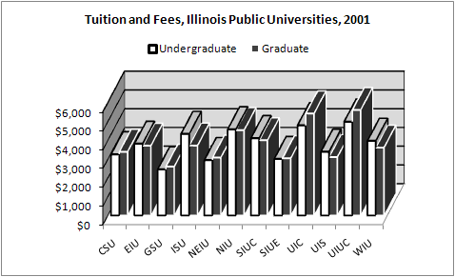 |  | From the Illinois Board of Higher Education.  Many things go wrong here:  - Rotated 3-D,.  - Alphabetical sorting.  - White borders on the graduate bar
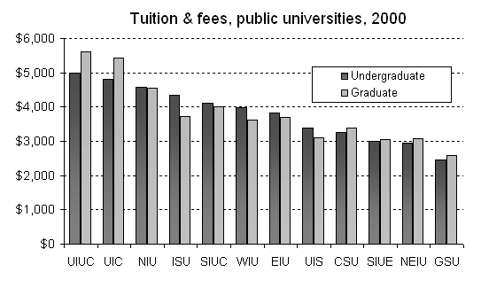 |  | Sorting these data permits you to quickly observe the high, low, and median universities, which schools charge less for graduate school than undergrad, and where your own school ranks.
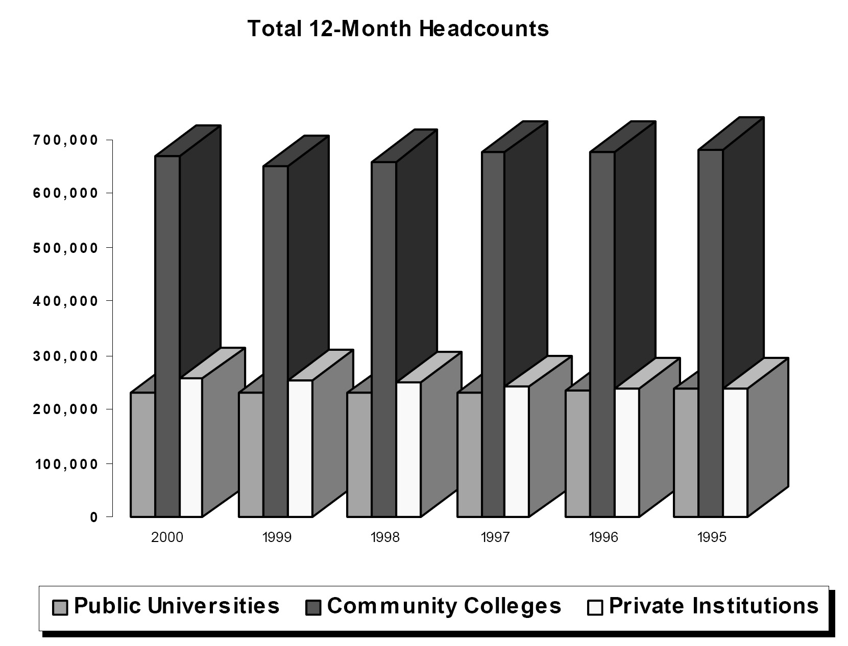  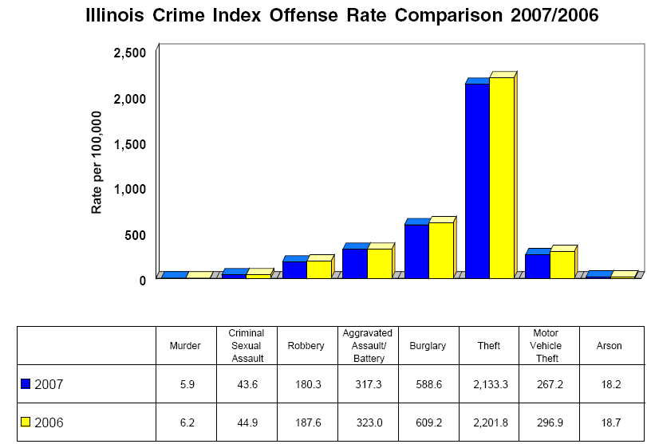 |  | Brought to you by the same folks who did the last one.  Part of the problem is the  3-D and part that the community colleges domin-ate the rest of the scale.  But the most serious problem is that time goes backwards.  It is almost impossible to tell from the chart that private school enrollments are increasing at a much faster rate than public university enrollments
 |  | Serious scaling problems here, and this is the second state of Illinois agency to have time go backwards
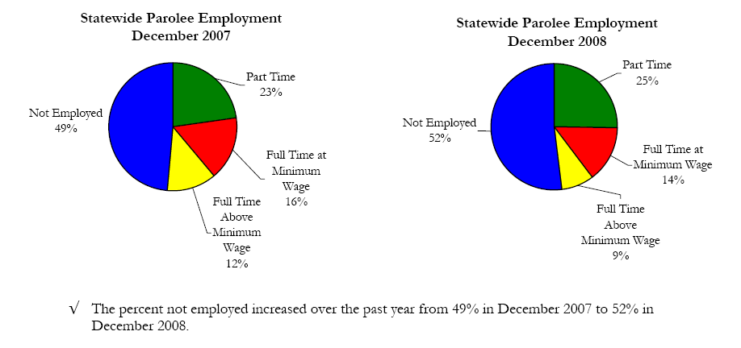

Bar charts aren’t too bad when only one slice is important, but it takes time when you try to compare two slices across two graphs.

Note how quickly the bar chart allows you to figure out that both categories of full time employment are in decline.

A Couple Excel Features: (2007)
Styles: The entire data range below uses the style “format as a table”, allowing one-click sorting of the data by each table column. The three data ranges are formatted using the style “format-data bars.” There are several limitations on the formatting of these styles (The cells are formatted with a dark “fill” because the bars are too light on the right) that are due to be corrected in the next release of Office. This table is sorted on the “Crime Index”:

The chart on the left is an “in-cell” chart using this formula, copied down the column:
=REPT("-",B2/15)&"X"

Note:
Inserting a blank in the REPT function (“ “) and “0” at the end of the formula produces a dot - plot.

Dot plots can be constructed as actual Excel charts: the Kelley O’Day or Jon Peltier websites provide examples.

Excel Chart Add-ins
Excel Chart Labeler: ($49)
J-Walk Power Utility Pack
http://spreadsheetpage.com/index.php/pupv7/
Note: the power utility pack contains an entire ribbon-menu of Excel functions, including Excel bookmarks.
There are several freeware chart labelers available on-line. The chart labeler is used not only for Excel charts,
but to label datapoints on other charts as well. Using a hidden horizontal variable, it can also be used to create
labels for uneven X-axis tick marks.

Boxplots: ($49)
Peltier Box and Whisker Plots
http://peltiertech.com/Excel/Charts/BoxWhisker.html
Note: Boxplots (without outliers) can be constructed by “hand” using variations on the Excel “stock” charts.

Sparklines (freeware)
Fabrice Rimlinger [sourceforge]
http://sourceforge.net/projects/sparklinesforxl/
Sparklines will be available in the next Office (2010) release.

Part II: Statistical Fallacies

- An argument: Premises (evidence and reasoning) offered in support of a conclusion.
- An argument fallacy: When the premises, even if true, do not support a conclusion
(Examples: false cause, slippery slope, ad hominem, straw man, red herring…).
- A statistical fallacy: When the data offered as evidence lead to the wrong conclusion.

Common statistical fallacies:

Cherry Picking: The arbitrary selection of data to support one’s conclusion.

Measurement validity: The indicator doesn’t really measure what it is assumed to measure.

Instrumentation or measurement reliability: Inconsistent measurement used in cross-time or cross-sectional comparisons. US infant mortality statistics are based on a different standard for recording live births than other countries use. Over time, improvements in police department recording of Index crimes may make it appear that crime is increasing. Hate crime data may be the most unreliable of any social indicator data.

False cause: This includes almost all of Donald T. Campbell’s threats to internal validity as well as spurious relationships, the Ecological Fallacy, reverse causation, Simpson’s paradox and the general post hoc ergo propter hoc fallacy.

Simpson’s paradox: A version of false-cause\ confounding-effect fallacies. A relationship between two variables may be completely reversed when examining the relationship within each subgroup of the population. In a university, male professors may earn more than women, yet earn less at every academic rank.

Experimental fallacies: sample mortality and maturation, testing effects, selection bias, Hawthorne effects, and multiple treatments.

Statistical significance fallacies: Assuming because there is no significant relationship that there is no relationship. Or, assuming because there is a statistically significant that the relationship is truly “significant”. Sampling error is usually the least important cause of measurement reliability. Survey response rate errors are far more serious.

The trend is not your friend: Smart stock market analysts know this but always seem to forget it when things are going really well.

Regression artifact or regression to the mean; Many medical remedies are assumed beneficial because patients are better after taking the remedy. Many government policies are assumed to work for the same reason. Policies implemented at times when there is an adverse jump or plunge in a social indicator are found to be effective when the indicator returns to its normal range (or regression to the mean).

Ecological Fallacy: What is true at the aggregate level may not be true at the individual level. In 1950, William S. Robinson observed that states with the highest rates of foreign-born population had the highest literacy rates, even though foreign born persons had lower rates of literacy.

False accuracy: Suppose a medical test is said to be 95% accurate. Ten percent of those tested have positive results. In fact, about half of those positive results will be false-positives. If nobody really had the disease, 5% of the results would be false-positive.

Rate of Change Fallacy: Comparing differences in rates of change between groups that begin at substantially different levels. Often found in arguments concluding that disadvantaged groups are “closing the gap.”

Cherry Picking:  How President Bush lowered the poverty rate* (Bill O'Reilly) | Cherry Picking:  Distribution of 248 z-scores in 17 political economy studies  --Tufte, Beautiful Evidence
“[after the full Reagan tax cut in 1983]…  income tax revenues climbed dramatically…  more than … 28% by 1989” (Mitchell) | Regression Artifact:  Senate Oil Price Speculation Bill and Crude Oil Prices*
Measurement Reliability:  Two Measures of Violent Crime (per 1,000 population) | Population Mortality:  Enrollment and First International Science Study Results, Final Year of Secondary School

Reserve Causation:  Prosecution Rate of Public Officials and Voter Turnout, 1980-‘04 | Reserve Causation:  Felony Arrest Ratio and Violent Crime Rate, 2008. New York Counties (excl. NYC)
The Trend is not your Friend:  Average Contract Price of New One-Family Houses  (2000 dollars) |  | Graphical Distortion:  Average Tuition and Fees: 4-year Public and Private Universities
Dominant Denominator:  “Bill Clinton and a GOP Congress balanced the budget by withdrawing a ‘peace dividend’ at a time when al Qaeda was declaring war” (2004). --WSJ 8/9/04  Clinton Defense budgets |  | Rate of Change Fallacy:  "Minorities in the U.S. increased their levels of homeownership at a faster clip than whites during the recent housing boom."  -WSJ 5/13/09
Rate of Change Fallacy: |  | Counter Evidence:

Measurement Reliability\Hawthorne Effect and People who Lie to Pollsters.

Graphical Distortion:  “Federal spending on K-12 education will top $41 billion in 2004. Add in state and local spending, and the figure rises to a record half-trillion dollars. That's double the amount spent in 1990 and a third more than the $375 billion the U.S. will spend on defense this year. The negligible impact of this ever-increasing cash infusion on reading scores is illustrated in this chart:”  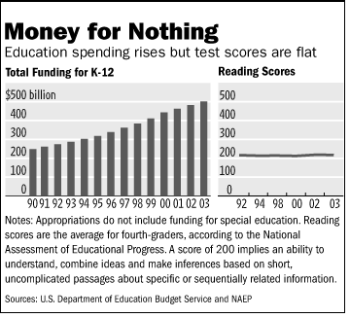 | Counter Evidence:

Recommended Readings on Charting and Graphic Design:
Cleveland, William S. The Elements of Graphing Data (NJ: Hobart Press, 1994)
Few, Stephen. Show Me the Number (Analytics Press, 2004).
Jones, Gerald E. How to Lie With Charts (iUniverse.com, 2000).
Kosslyn, Stephen M. Elements of Graph Design (New York: W. H. Freeman, 1994).
Miller, Jane E. “Creating Effective Tables”, “Creating Effective Charts,” The Chicago Guide to Writing about Numbers, (University of Chicago Press, 2004). Chapters 6& 7.
Tufte, Edward R. The Visual Display of Quantitative Information (Cheshire: Connecticut: Graphics Press, 1983).
___________. Visual Explanations—Images and Quantities, Evidence and Narrative (Cheshire: Connecticut: Graphics Press, 1997).
Wainer, Howard. Visual Revelations: Graphical Tales of Fate and Deception from Napoleon Bonaparte to Ross Perot. (Mahwah, NJ: Lawrence Erlbaum Associates, 1997).
___________. Graphic Discovery (Princeton University Press, 2005).
Wallgren, Anders, et. al. Graphing Statistics & Data (Sage Publications, 1996).

Statistical Fallacies:
Campbell, Donald T. and H. L. Ross. "The Connecticut Crackdown on Speeding: Time Series Data in Quasi-Experimental Analysis." Law and Society Review 2: 33-53. (1968)
Campbell, Stephen K. Flaws and Fallacies in Statistical Thinking (Prentice-Hall, 2004)
Gorard, Stephen. “Keeping a Sense of Proportion: The ‘Politician’s Error’ In Analysing School Outcomes,” British Journal of Educational Studies, 47, no. 3, (September 1999): 235–46.
Ross, H.L., Campbell, D.T., Glass, G.V. “Determining the social effects of a legal reform: The British "breathalyser" crackdown of 1967”. American Behavioral Scientist, 13(4), 493-509 (March, 1970)
Wainer, Howard. Picturing the Uncertain World (Princeton University Press, 2009)

Key websites:
Gary Klass, Just Plain Data Analysis: Companion Website http://lilt.ilstu.edu/jpda/
Kelley O’Day, Data Visualization & Excel Charts http://processtrends.com/ The website describes many bad charts and how they might be made better and also covers the R (freeware) charting software.
Jon Peltier, Peltier Technical Services Charting in Microsoft Excel
http://peltiertech.com/Excel/Charts/
Peltier’s website provides instructions for constructing large number of combination charts, charts with text Y-axes, “broken axis” charts, variations on area charts that color specific plot area ranges. The BoxPlotter is among his several Excel add-ins.
Milo Schield, StatLit.Org http://www.statlit.org/ This is the headquarters for the movement for teaching statistical literacy skills in high school and college.
John Walkenbach, The Spreadsheet Page http://spreadsheetpage.com/index.php/tips
Walkenbach has published many Excel books. His “Tips” page contains many very useful Excel tips and tricks, both for charting and managing the Excel spreadsheet. His Power Utility Pak ($49) is an Excel add-in that adds dozens of new features and functions to Excel including Excel bookmarks and an excellent chart-labeller.
Excel Charting Newsgroup: microsoft.public.excel.charting . Whenever you discover that something is impossible has happened in Excel, send a help request to this newsgroup. They often provide a solution within minutes.

