Excel 2007 Charts and Graphs
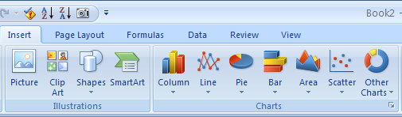
The Excel 2003 charting engine looked tired and old. Little had changed in 15 years in charting. The popular chart wizard has been replaced in Excel 2007 by a set of dedicated buttons and groups located on the ribbon, simplifying the chart creation process.
Click on the Insert tab of the ribbon and select from the charts category

Creating a Chart in Excel 2007
Creating a chart involves four broad steps:
- Prepare your data. Make sure that you have headings above and to the left of the data to be charted. If one of the headings has date or numeric fields, leave the top-left corner cell blank. Select the range of data to be charted.

 | Jan | Feb | Mar
East | 75748 | 90879 | 99540
Central | 65897 | 72487 | 79736
West | 82974 | 66379 | 73017
Leave the top left cell
blank when your headings
are dates.

- Choose one of the broad chart types from the gallery on the Insert ribbon. Although there are 70+ chart types, there are often three or four variations of each type.
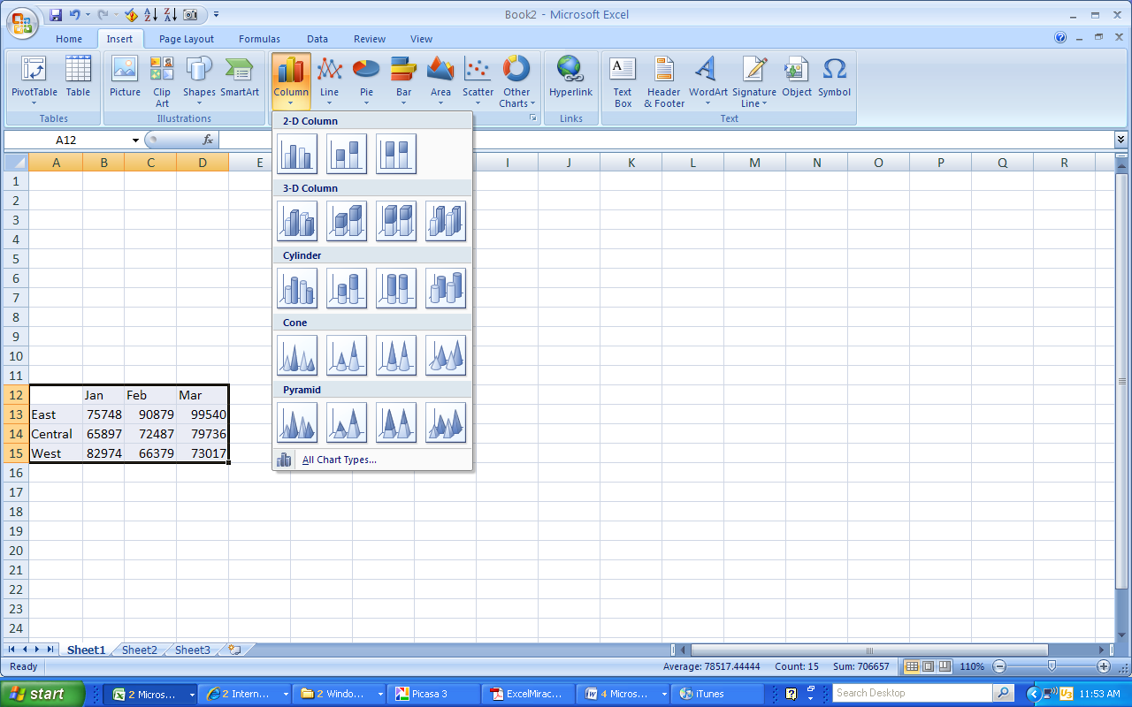
Choose a subtype from
the dropdown menu.

Most chart types come in variations where series are plotted side by side, stacked, or
100% stacked.
- Visit the Chart Tools Design ribbon to choose a Chart Layout and a Chart Style. Chart Layouts offer up to a dozen different views of the same chart.
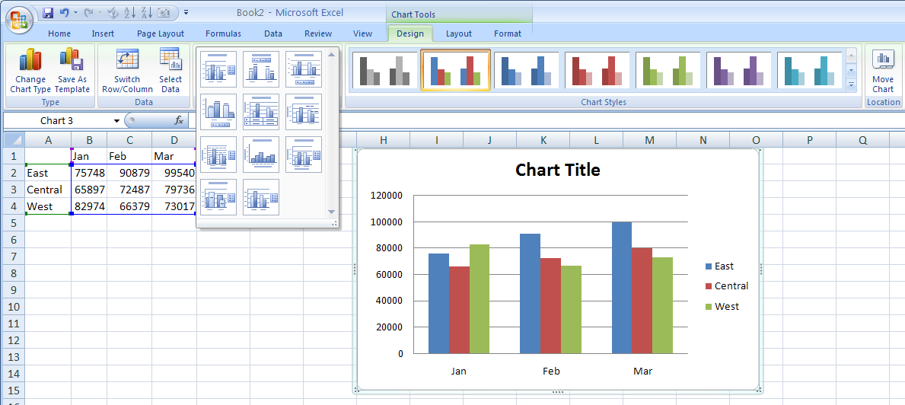

The Chart Styles gallery offers 48 color combinations built around the current theme. If you will
be copying the chart to PowerPoint, you can use the new darker layouts to match the background of your slide.
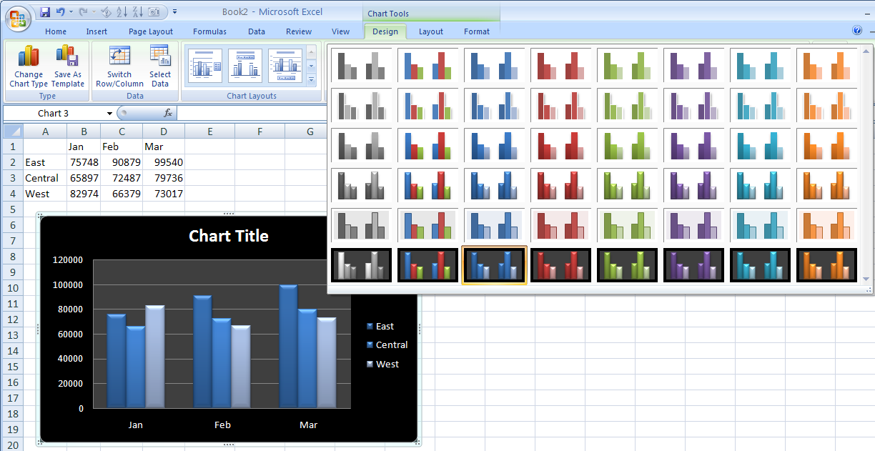
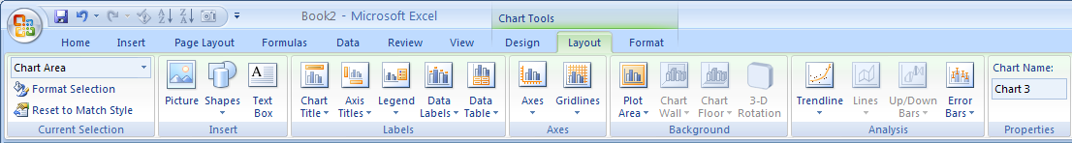
- If the built-in style didn’t perfectly provide axis titles, legends, etc., visit the Layout ribbon to have easy editing choices for all chart elements.
For more granular control, visit the Format ribbon, where you can apply an effect to any particular element in the chart.
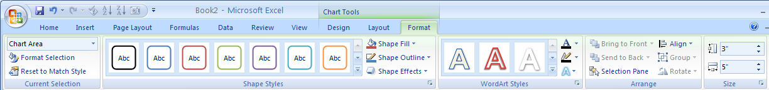
Use the Format ribbon to apply
an effect to a particular chart
element.

Using Other Chart Types
In a Scatter chart, your data should contain pairs of numbers. Excel will find the first number
along the horizontal access and the second number along the vertical axis and add plot a marker at the intersection of those values. This chart works well for seeing if two variables are related.
Each point represents the
intersection of an X, Y pair.

For the Stock Charts, your data must be in the exact order specified by the name of the chart type.
The High-Low-Close chart is one of four stock charts available.

Pie Charts are percentage charts that are effective in displaying the proportional relationship of values within one data series. Descriptive headings (categories) on the worksheet should be listed in one column, with the related data placed in the next column. Remember that pie charts will not display zero or negative values, that no more than seven categories can be used, and that the categories should represent parts of the whole pie.

Adding New Data to a Chart
Say that you have produced a series of charts last month and now you need to update all of those charts to reflect a new month of data. Follow these steps:
- Open the workbook from last month. Type the new month’s data adjacent to the old month’s data in the workbook.
- Click on the plot area of the chart. A blue rectangle appears around the range of data currently plotted on the chart. Notice that there are blue square handles in each corner of the range.
Range of Data
Drag the handle to the
right to include the new
October data.

Plot Area

After dragging the handle,
the chart updates to include
the new month.

Custom Chart Templates

If you create a chart that might be useful in the future, you can save that chart as a template.
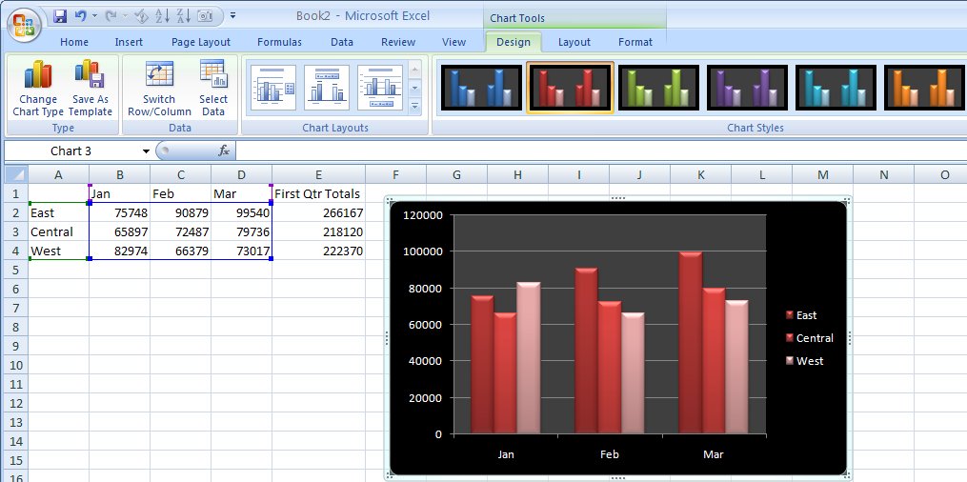
To create a custom template: Click on the chart with a formatting setup you want to reuse in the future and, under the design tab, in the type group, click Save as Template. In the Save Chart Template dialog box, enter a name for the template in the File name field and click Save.
To use a saved chart template:
- Highlight the data you want to use for the chart
- Under the Insert tab, click the desired chart type (e.g. Column, Line) from the Charts gallery, and select All Chart Types from the dropdown menu.
- In the Insert Chart dialog box, click Templates. Select the desired chart template from the available options and click OK.
Tip: Click Manage Template in the Insert Chart dialog box to open the folder where Excel chart templates are stores on your computer. From here, you can copy favorite templates to a backup folder or even send them to other people!

