Multivariable Calculus
Quadric Surfaces and Advanced Graphing

- INTRODUCTION

Calculators and computers make new modes of instruction possible; yet, at the same time they pose hardships for school districts and mathematics educators trying to incorporate technology with limited monetary resources. In the Standards, a recommended classroom is one in which calculators, computers, courseware, and manipulative materials are readily available and regularly used in instruction [2, p. 243]. This paper outlines a solution that is affordable for classrooms with computers but limited software availability. Special attention will be given to incorporating the free math add-in that is found in Microsoft Word 2007 into the calculus classroom. This paper gives specific examples highlighting the graphic and equation capabilities. However, the technology is not limited to this focus. Any license holder of Microsoft Word 2007 may download the software from www.microsoft.com. Hence, many students will have at home a mathematical tool that can be incorporated with word processing assignments.
- GRAPHING SURFACES
After downloading the math add-in, a Microsoft Math button will be added to the ribbon and have students use the Insert New Equation for an input [1]. See Figure 2.1.
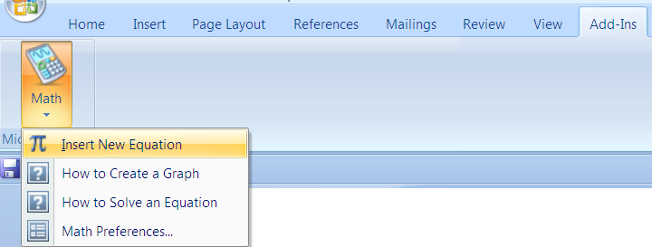
Figure 2.1
The graph of the elliptic paraboloid z = $2x^{2}+y^{2}$ and its tangent plane $z=4x+2y-3$ when x = 1 and y = 1, can be graphed simultaneously [7, p. 960]. Students should insert each separately and then highlight jointly both equations by dragging using the left button on the mouse. The image shown is seen in Figure 2.2
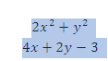
Figure 2.2 Highlight.

Have students right click within the shaded region. The menu seen in Figure 2.3 will appear.

$$2x^{2}+y^{2}$$
$$4x+2y-3$$

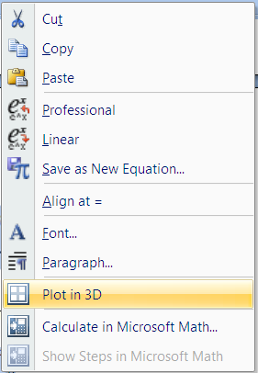
Figure 2.3 Plot in 3D.

Alternatively, the Plot in 3D option appears after clicking on the down arrow at Math as shown in Figure 2.4. A pull down menu, as shown in Figure 2.5, will appear. Selecting Plot in 3D and the Rotate button captures a viewpoint that illustrates the plane is tangent to the curve as seen in Figure 2.6.

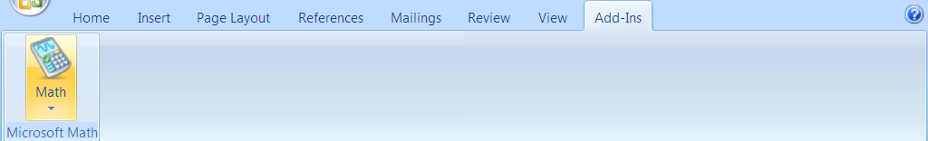
Figure 2.4 Math.

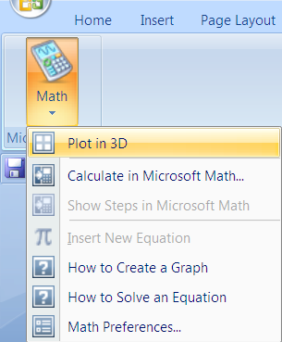
Figure 2.5 Plot in 3D.

Students may recognize that the surface is not defined below the x- y plane and is unbounded above. The sections parallel to the x-y plane are ellipses, where the sections parallel to the other coordinate planes are parabolas.

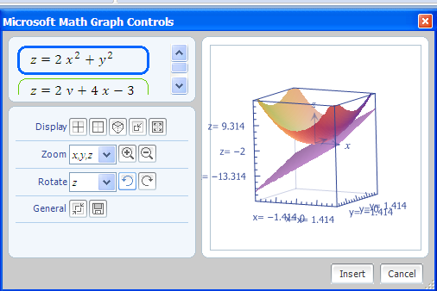
Figure 2.6 The graphs of z =$2 x^{2}+ y^{2}$and z = $4x+2y-3$

Students should consider a quadric surface which is a hyperboloid of one sheet such as, $z^{2}+ 1= x^{2}+y^{2}/4$. It can be graphed without the axes and units displayed by using the icons in the Display menu. Students should be directed to find the trace in the x-y plane is an ellipse and the traces in the other coordinate planes are hyperbolas as shown in Figure 2.7. The curve is rotated about the y-axis for a fine visual effect.

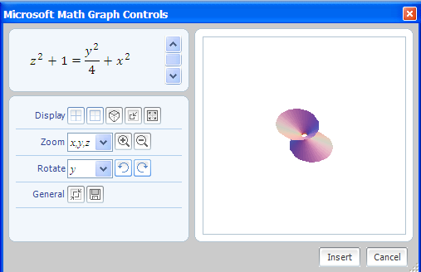
Figure 2.7 Hyperboloid of one sheet.

- CREATING A MOVIE USING TWO SURFACES
The next example will assume students understand the ceiling (or floor) function. A list of other functions may be found at: http://web02.gonzaga.edu/faculty/nord/wordusersmanual/builtinfunctions.docx
The command ceiling yields the right most integer for a given input. Similarly, the command floor yields an integer that is closest to the left of an input. If the input is an integer in either case, the output will be the original input value. For example, floor 3.22 = 3 and ceiling 3.22 = 4.
Students should discover that the Animate option appears by default in two-dimensions when using a letter other than x and y with Cartesian coordinates and r with polar coordinates. For three-dimension, using variables other than x, y and z will produce the Animate option. The variables, r, s, and t, are used to graph polar three-dimensional surfaces and curves and typically should not be used as an animation variable. The user is allowed to toggle values for the variable, such as a, that is defined. See Figure 3.1. Students may opt to play a movie, where the variable is allowed to increment in time.
The students have the tools now to create a customized movie where the picture oscillates back-and-forth from two quadric surfaces such as a hyperbolic paraboloid, $z=x^{2}-y^{2}/4$ and an elliptic paraboloid, $z=x^{2}+y^{2}/4$. The students will need to first define a variable, a, to animate on. The command ceiling a will always yield an integer. Therefore, ${(-1)}^{ceiling a}$ will take on only two values, -1 or 1 . After selecting Plot in 3D, have students select the domain for a. For larger values of a, the oscillation will increase. Let a =16 for example. The input the students should be able to realize that works is $z=x^{2}+{(-1)}^{ceiling a} y^{2}/4$. The two quadric surfaces that will alternatively appear will be a hyperbolic paraboloid, as shown in Figure 3.2, and an elliptic paraboloid.
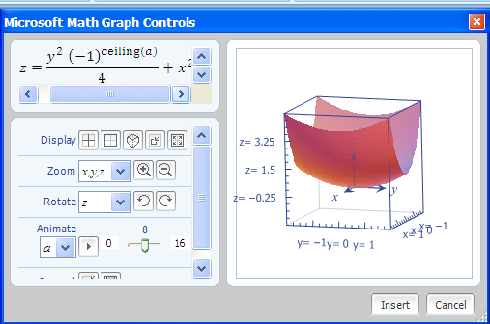

Figure 3.1 Toggle values.

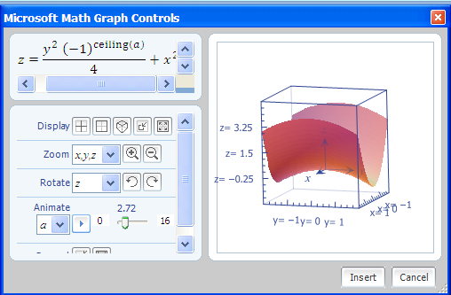

Figure 3.2 Create animation.

4. FURTHER GRAPHING FEATURES

Other features in the free math add-in include the capability to graph points, curves, and surfaces in two dimensions or three-dimensions using Cartesian, polar, parametric and cylindrical coordinates. Using Table 4.1, the students can be left to explore the many other graphing features and find patterns for the behavior of particular types of functions, curves, and surfaces. The absence, in some cases, of a command is permissible. The pull-down menu will have options such as Plot in 2D and Plot in 3D added for some examples, depending upon the input and the omission.

Command | Example | Notation Requirements | Drop- Down Menu Option to Execute
plot | $$plot(3*x^{2}+12*x)$$ | Input function, f(x). | Simplify
plot3D | $$plot3D(x+y^{3})$$ | Input where, z=f(x, y). | Simplify
plotCylDataSet3D | $$plotCylDataSet3D(\{\left\{1, 2, π\right\}, \left\{3,\frac{π}{2},\frac{3π}{2}\right\}\})$$ | Data point is {$r, θ,z\}.$ | Calculate
plotCylParamLine3D | $$plotCylParamLine3D(\cos\left(t\right),\sin\left(t^{2}\right), t^2)$$ | Insert $r=f\left(t\right), z=g\left(t\right), θ=h\left(t\right).$ | Simplify
plotCylR3D | $$plotCylR3D(r^{2}+\cos\left(3θ\right))$$ | Input z=f(r, $θ).$ | Simplify
plotDataSet | $$plotDataSet(\{\left\{2, 3\right\}, \left\{5, -1\right\}\})$$ | Input point, {x, y}. | Calculate
plotDataSet3D | $$plotDataSet3D(\{\left\{30, 2, 9\right\},\left\{-4, 8, 20\right\}\})$$ | Input point, {x, y, z}. | Calculate
plotEq | $$plotEq(x^{2}+y^{2}=9)$$ | Input f(x, y) = c. | Simplify
plotEq3D | $$plotEq3D(\frac{x^{2}}{4}+y^{2}+z^{2}=1)$$ | Input f(x, y, z)=c. | Simplify
plotIneq | $$plotIneq(x≤3+y)$$ | Input inequality in x and y. | Simplify
plotParam | $$plotParam(\sin{t, t^2)}$$ | Input (f(t), g(t))where x=f(t) and y=g(t). | Simplify
plotParam3D | $$plotParam3D(t+s, t+3s, t-s)$$ | Input (f(t, s), g(t, s),  h(t, s)) where x=f(t, s) and  y=g(t, s) and z=h(t, s). | Simplify
plotParamLine3D | $$plotParamLine3D(\cos{t, t+2, t)}$$ | Input (f(t), g(t), h(t)) where x=f(t) and y=g(t)and z=h(t). | Simplify
plotPolar | $$plotPolar(3×\sin{θ)}$$ | Input $r=f\left(θ\right).$ | Simplify
plotPolar3D | $$plotPolar3D(3θ-φ)$$ | Input $r=f(θ, φ)$. | Simplify
plotPolarDataSet | $$plotPolarDataSet(\{\left\{2,\frac{π}{3}\right\}, \left\{8, -\frac{π}{2}\right\}\})$$ | Input point {$r, θ\}.$ | Calculate
plotPolarDataSet3D | $$plotPolarDataSet3D(\{\left\{3,\frac{π}{2},π\right\},\left\{-2,\frac{π}{4},\frac{π}{4}\right\}\})$$ | Input a point, {$r, θ, φ\}.$ | Calculate
Table 4.1 Graphing in two dimensions and three dimensions.

An extension after the graphing exploration is to give a shape to the students, and have them find a way to resemble and create it graphically. For example, the shape given might be a tear-drop as shown in Figure 4.1 or a shell as shown in Figure 4.2. Students should be advised that solutions for a given shape are not necessarily unique.

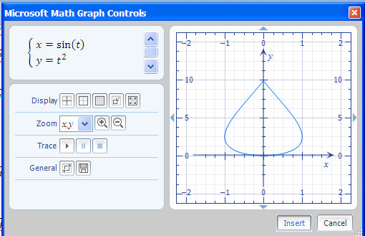

Figure 4.1 Graph in parametric form of (sin (t), $t^{2}).$ $plotParam(\sin{t, t^2)}$

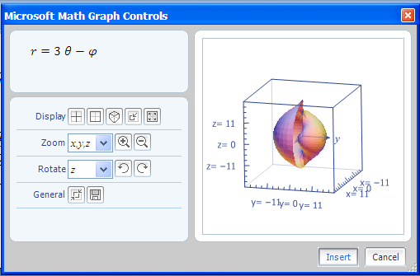
Figure 4.2 Graph in polar form of $r=3 θ-φ$.

5. EQUATIONS

The free math add-in can also be used by students to solve a single equation or a system of equations. An example involving a system of equations in a multivariable calculus course is as follows, ‘At what point do the curves, r₁(t)= <t,3+t²> and r₂(s)= <3-s,s²> ,intersect?’. Students may solve this problem numerically with the nsolve command. Consider the input:
$$nsolve(\left\{t=3-s, 3+t^{2}=s^{2}\right\})$$

A right click within the input line, followed by selecting Simplify from the pop-up window, yields the output:
$$\left\{\begin{aligned} t&≈1 \\ s&≈2\end{aligned}\right.$$

Alternative syntax involving the nsolve command will allow students to search specific interval(s) for specified variable(s) such as in the following example:
$$nsolve(\{x\sin{y}=\frac{1}{4},x-y=8\},\{\left\{x\right\},\left\{y,0,2π\right\}\})$$
The solution is:
$\left\{\begin{aligned} x&≈8.0311338842625 \\ y&≈0.0311338842625\end{aligned}\right.$ .
Microsoft Math allows changes to the preferences’ setting.
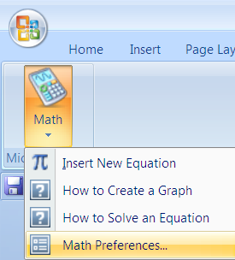
Figure 5.1 Math preferences.
For the previous example, Math Preferences was used to establish the angle in radian mode as shown in Figure 5.1. Real Numbers or Complex Numbers are also options that can be controlled.
The nsolve command can be used to solve problems with n-equations in n-unknowns.
Here the command:
$$nsolve(\left\{xsin\left(y\right)=z, x+y+z=20, x-y=2\},\{\left\{x\right\},\left\{y\right\},\left\{z,.3\right\}\right\})$$

produces the solution: $\left\{\begin{aligned} x&≈14.1098720475624 \\ y&≈12.1098720027676 \\ z&≈-6.2197440085919\end{aligned}\right.$.

The solution was obtained by inputting an initial value for the search on a particular variable, z. If a range or initial value is omitted in a problem, the search for the solution will be anywhere on the real number line.

Similarly, nsolve can be used to solve a linear system such as:

$$nsolve(\left\{x+y+z=3,x-y+z=2,x-y-z=-1\right\})$$

Notice that the answer is exact even though the output indicates an approximate solution.

$$\left\{\begin{aligned} x&≈1 \\ y&≈0.5 \\ z&≈1.5\end{aligned}\right.$$

Non-linear examples are also possible. An example of a non-linear problem along with its solution follows.
$$nsolve(\left\{xsin\left(y\right)=.5,x^{2}+y=10\right\})$$

$$\left\{\begin{aligned} x&≈3.1368650605934 \\ y&≈0.1600775916285\end{aligned}\right.$$

Consider the problem with a solution involving integers:

$$nsolve(\left\{x+y=2,x+z=2,y+z=2\right\})$$

The answer is, $\left\{\begin{aligned} x&≈1 \\ y&≈1 \\ z&≈1\end{aligned}\right.$.

Students can quickly produce graphs to check the feasibility of this solution by graphing the three planes as shown in Figure 5.2. Concurrent visualization always fosters understanding. Consider the input:
$$show3d(plotEq3d\left(x+y=2\right),plotEq3d\left(y+z=2\right),plotEq3d(x+z=2))$$

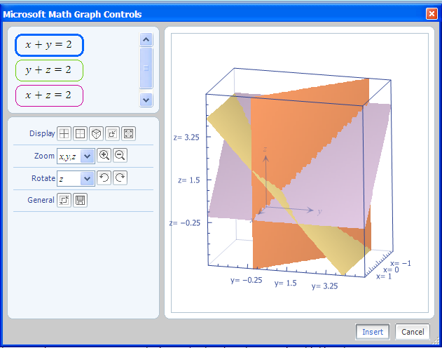
Figure 5.2 Three planes.

The show3D command allows the display of more than one three-dimensional curve using one input line. In conclusion, the nsolve command found within the Word Math Add-In always displays the result as an approximate solution, even though the solution may be exact. An allowable input should have the number of equations equal to the number of variables.
6. INTEGRALS

There are limitations to the software. Here is an example of a single variable integral it will not compute. The example input below yields an equivalent output:

$$\int_{1}^{5}{t\sqrt{t-1}} dt$$
$$\int_{1}^{5}{\sqrt{t-1} tⅆt}$$

At times, Word Math has difficulty working with square roots. The evaluation at t = 1 will involve a radicand which is zero, which appears to be the problem. Changing the value of t=1 to t=1.5 will create a problem that can be evaluated.

Input for multiple integrals can be accomplished by following these steps.
First select the Integral tab as shown in Figure 6.1.

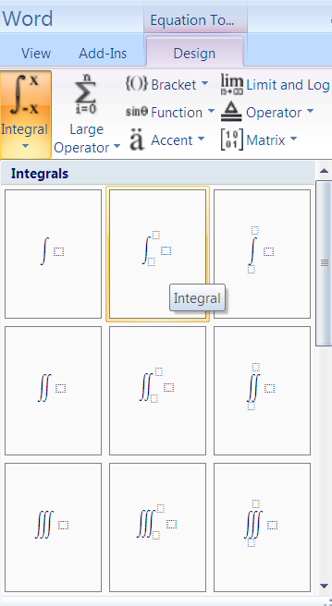
Figure 6.1 Integral tab.

To produce a definite integral, input values for a and b as shown below in Figure 6.2:

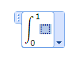
Figure 6.2 Set-up.

Then, select and apply the Integral command to the blue shaded region as shown in Figure 6.3.

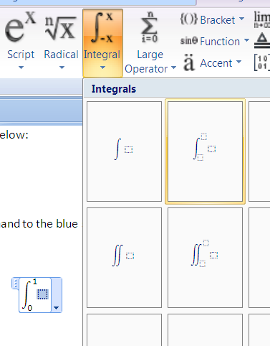
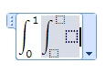
Figure 6.3 Set-up a double integral.

The following double integral,
$$\int_{0}^{1}{\int_{0}^{x}{y}dy}dx$$

produces this output
$$\frac{1}{6}$$
A double integral such as:
$$\int_{0}^{\frac{π}{2}}{\int_{0}^{\sin{x}}{y}dy}dx$$

even yields a closed-form solution such as:
$$\frac{π}{8}$$

An example of a multivariable integral that will not produce a solution from within Word is:
$$\int_{1}^{5}{\int_{1}^{x}{\sqrt{y-1} dy}dx}$$
Mathematica (not a free technology) produces 128/15 as the answer. The problem with the radicand being zero still exists with double integrals.

Problems involving a u substitution are possible. Below is a problem with its answer.

$$\int_{12}^{x}{y \sqrt{y^{2}-1}ⅆy}$$

$$\frac{{\left(x^{2}-1\right)}^{\frac{3}{2}}-143 \sqrt{143}}{3}$$

See an application of the Fundamental Theorem of Integral Calculus on this example, by right clicking within the input line and selecting Differentiate on x as shown in Figure 6.4.
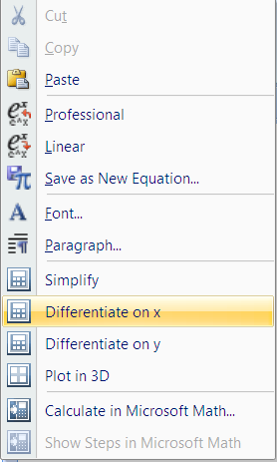
Figure 6.4 Differentiate on x.

The output is:

$$x \sqrt{x^{2}-1}$$

This tool offers students the ability to readily discover the Fundamental Theorem. A similar example illustrating a u substitution problem is as follows:

$$\int_{1}^{x}{y \sqrt[3]{y^{2}+1}ⅆy}$$

The correct output is:

$$\frac{3 {\left(x^{2}+1\right)}^{\frac{4}{3}}-3·2^{\frac{4}{3}}}{8}$$

There is an alternate way to evaluate definite and indefinite integrals by using the integral command. The integration constant is not included for some indefinite integrals. When considering an indefinite integral, input using the syntax:
integral(function, variable of integration)$.$ An indefinite integral example, $\int{\sqrt{y+1}dy}$, would have the input:
$$integral(\sqrt{y+1},y)$$
The output is:
$$\frac{2 {\left(y+1\right)}^{\frac{3}{2}}}{3}+С$$

To evaluate a definite integral, use the syntax:
integral(function, variable of integration, lower limit of evaluation, upper limit of evaluation).
With more than a single integral, embed the integral symbol. The following example executes with the integral command, but does not execute without it. Consider the double integral,
$\int_{3}^{5}{\int_{5}^{x}{\sqrt{y+1}dy}dx}$.
The executable input line is:
$$integral(integral\left(\sqrt{y+1}, y, 5,x\right),x, 3,5)$$

After selecting Simplify, the output is:
$$\frac{4·6^{\frac{5}{2}}}{15}-\frac{24 \sqrt{6}}{3}-\frac{128}{15}$$

As shown in Figure 6.5, right click and select Calculate.

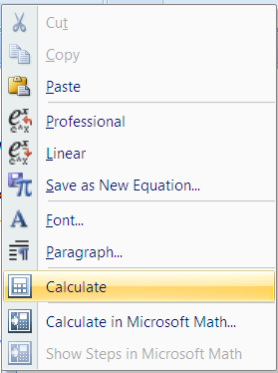
Figure 6.5 Calculate command.

The output shows the second term has been simplified. Select Calculate again to give a numerical answer. Below is the double execution of the Calculate command with our original example.
$$\frac{4·6^{\frac{5}{2}}}{15}-8 \sqrt{6}-\frac{128}{15}$$
$$-4.6141497449$$

7. CONCLUSION

The use of the animate command and graphics are not limited to the topic of quadric surfaces as shown in sections 2 and 3. The Microsoft Word 2007 free math add-in can be used as a teaching and learning aid throughout the mathematics high school and undergraduate curriculum. As identified by the National Research Council [5, 84], “calculators and computers are not substitutes for hard work or precise thinking, but challenging tools to be used for productive ends.” The computation capacity of technology tools extends the range of problems accessible to students [4, 25]. The free math add-in provides an available option as a computer algebra system that will enhance student learning.
The Microsoft Word Math Add-In and MathType are not compatible. If MathType is installed concurrently on the computer, the Add-In will function intermittently or not at all. The MathType software may be temporarily disabled by following the instructions found at, http://web02.gonzaga.edu/faculty/nord/wordusersmanual/troubleshooting.docx.
For extended examples, links to downloads, and materials appropriate for other mathematical curricular topics, see: http://web02.gonzaga.edu/faculty/nord/links.htm.

8. REFERENCES

1. Microsoft Word 2007 Math Add-In, http://www.microsoft.com/downloads/details.aspx?FamilyID=030fae9c-704f-48ca-971d-56241aefc764&DisplayLang=en
2. National Council of Teachers of Mathematics (NCTM), Curriculum and Evaluation Standards for School Mathematics, NCTM, Reston, VA, ISBN 0-87353-273-2 (1989).
3. National Council of Teachers of Mathematics (NCTM), Professional Standards for Teaching Mathematics, NCTM, Reston, VA, ISBN 0-87353-397-0 (1991).
4. National Council of Teachers of Mathematics (NCTM), Principles and Standards for School Mathematics, NCTM, Reston, VA, ISBN 0-87353-480-8 (2000).
5. National Research Council, Everybody Counts: A Report to the Nation of the Future of Mathematics Education, National Academy of Sciences, Washington D.C., ISBN 0-309-03977-0 (1989).
6. S. Salas, E. Hille, and G.J. Etgen, Calculus One and Several Variables, Eighth Edition, John Wiley & Sons, NY, ISBN 0-471-31659-8 (1999).
7. J. Stewart, Calculus. Fifth Edition, Thomson Learning, Belmont, CA, ISBN 0-534-27408-0 (2003).

Multivariable Calculus
Graphing

Example 1: Plot the level curve f(x, y) = sin x + sin y (Stewart, 2003, page 928).
Highlight and right click on the following:

$$\sin{x+\sin{y}}$$

Select Plot in 3D. The input was an equation assumed equal to z.
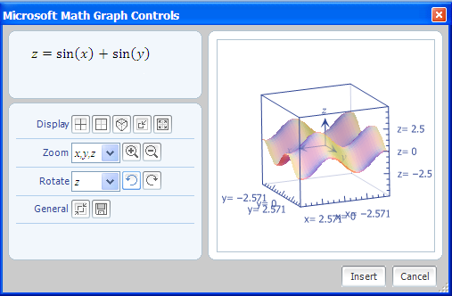

Example 2: Graph f (x, y) = sin (|x| + |y|) (Stewart, 2003, page 935).

$$\sin{((abs\left(x\right)+abs\left(y\right))}$$

Use the recognized function abs to execute an absolute value. Use the Zoom feature to look at the graph from different inputs for x and y.

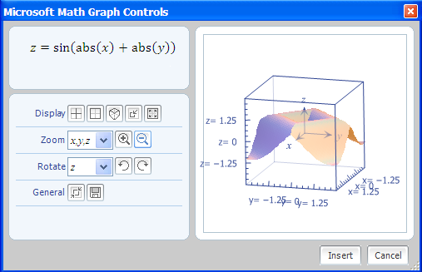

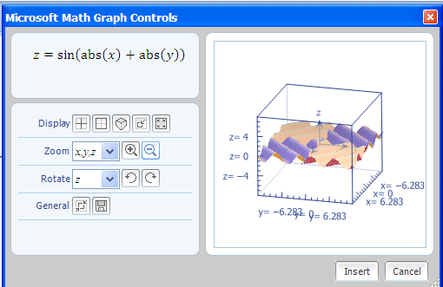

Multivariable Calculus
Graphing
Input something like this in Linear form, $e^(-x^{2}+y^{2})$ , and then convert to, Professional form and select, Plot in 3D.

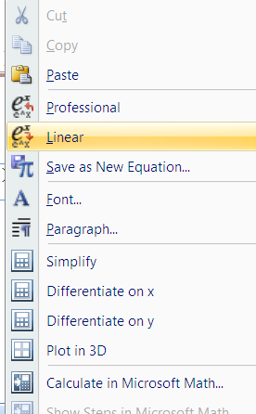
The output is:
$$e^{-x^{2}+y^{2}}$$
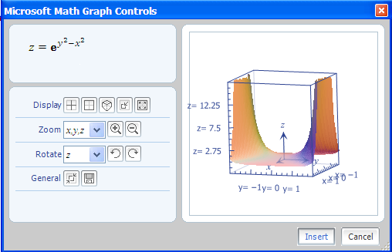

Example 3: Graph a three-dimensional equation not in the form, z = f(x, y).

$$x^{2}+\frac{y^{2}}{16}+\frac{z^{2}}{9}=1$$
Select Plot in 3D to yield:
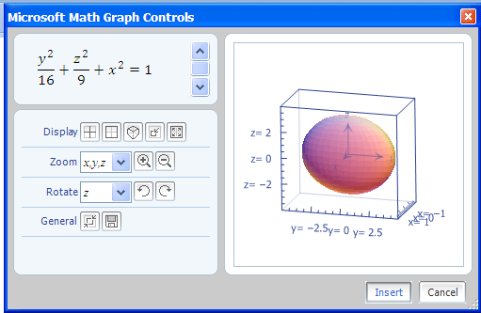
Click for a live animation of the ellipsoid using Rotate.
Graphing multiple surfaces is possible. You can graph multiple 3D equations on the same axis with the same animation options. Drag hold down the left mouse button to highlight both equations. Right-click and select Plot in 3D from the pop-up menu.
$$\frac{x^{2}}{9}+\frac{y^{2}}{4}+\frac{z^{2}}{16}=1$$
$$x^{2}+\frac{y^{2}}{25}+z^{2}=1$$
The screen will appear as shown when both equations are highlighted simultaneously.
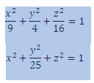
The graph is:
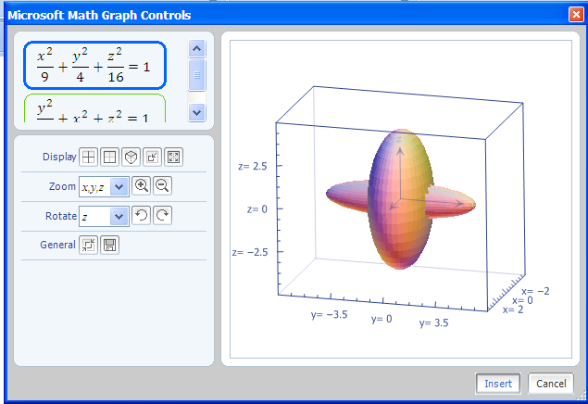

Example 4: Use the Show3D command to plot simultaneous surfaces in a single Insert New Equation line.
To input an equation $c=f(x, y,z)$ and there is no variable such as z, then use zero times the variable as a place holder. Consider the two surfaces:
$$\frac{x^{2}}{9}+\frac{y^{2}}{4}+\frac{z^{2}}{16}=1$$

$$x^{3}-y+0z=6$$

Use the plotEq3D with the equation and separate each with a comma. The input is:
$$show3D(plotEq3d\left(\frac{x^{2}}{9}+\frac{y^{2}}{4}+\frac{z^{2}}{16}=1\right),plotEq3d\left(x^{3}-y+0z=6\right))$$

The graph is:
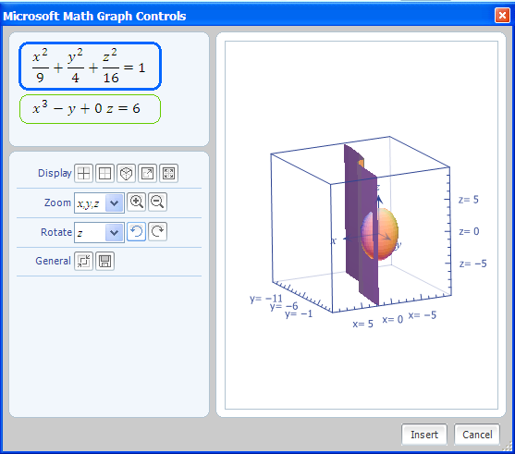

Example 5: Graph the following:

$$r=(1-2\cos{3θ)}φ$$
Input the angles using Symbols.
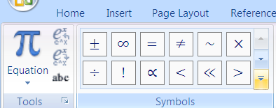
Use pull-down to bring up more.
Symbols

Right-click and select Plot in 3D to give the graph:
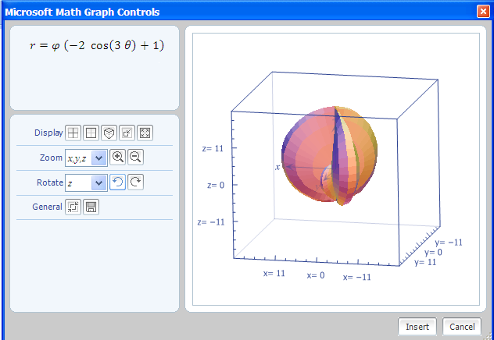

Reference:
Stewart, James. Calculus. 5th ed. Belmont, CA: Thomson Learning, 2003.

Multivariable Calculus
Integrals/Limits/Graphs

Here are some examples of a few of the advanced mathematical features in the Word 2007 math add-in.
Consider an indefinite integration problem with an integral on both sides of an equation. There will be no integration constant displayed.
Example 1: Consider the problem and solve:
$$\int{ydy}=\int{1/xdx}$$
Right click and the following menu will appear:
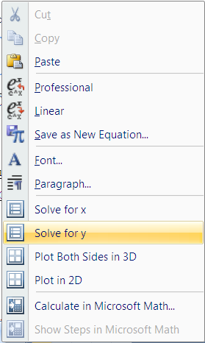
Select Solve for y and the output is:
$$\begin{aligned} y=\sqrt{2\ln\left(\operatorname{abs}\left(x\right)\right)} \\ y=-\sqrt{2\ln\left(\operatorname{abs}\left(x\right)\right)}\end{aligned}$$
Select Solve for x and the answer is:
$$\begin{aligned} x=e^{\frac{y^{2}}{2}} \\ x=-e^{\frac{y^{2}}{2}}\end{aligned}$$
Example 2: Select Plot in 2D for a similar equation:
$$\int{1dy}=\int{xdx}$$
The resulting parabola is:
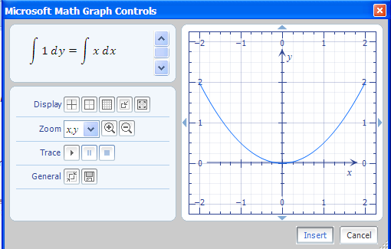
Notice that the graph is correct, but displays the equation in the original form.
Example 3: With an example, use the Plot Both Sides in 3D option.
Consider:
$$\int{\frac{1}{x}dy}=\int{1 dx}$$
Right click and the following menu will appear:

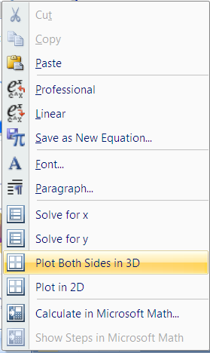
Each side of the equation is set equal to z and the resulting two surfaces appear concurrently.
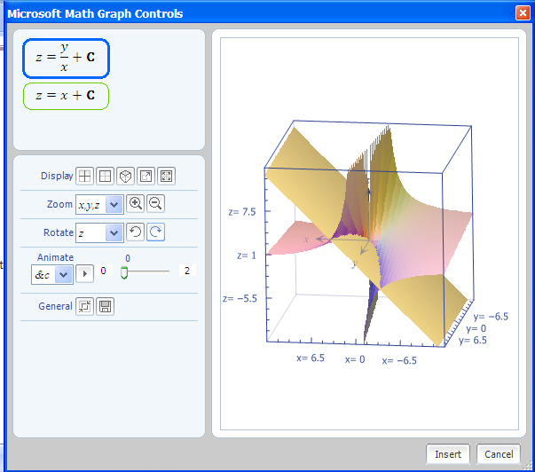
The integration constant, C, does appear and animation is allowed.
There are problems working with differential equations. The Fraction button on the ribbon will allow input of the derivative of y with respect to x. However, it is not understood as this.
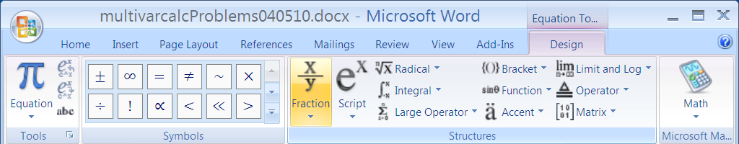
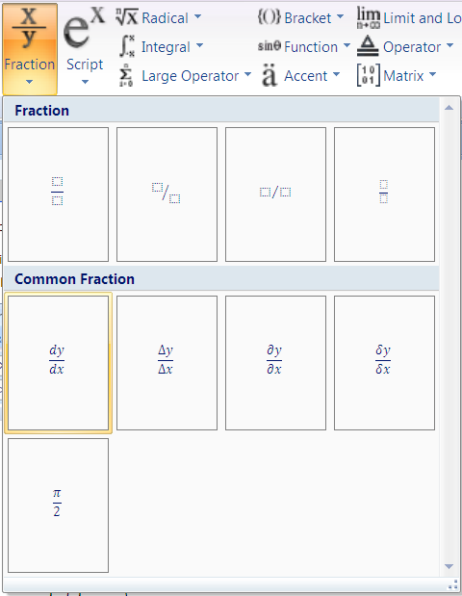
With the following example, the letter d is understood as a variable:
$$y=\frac{dy}{dx}$$
Example 4: Evaluate a definite double integral.
The input:
$$\int_{1}^{5}{\left(\int_{0}^{1}{x }dx\right)} dy$$
Is obtained by first setting up: $\int_{1}^{5}{}$
In the box, embed another integral using the following option:
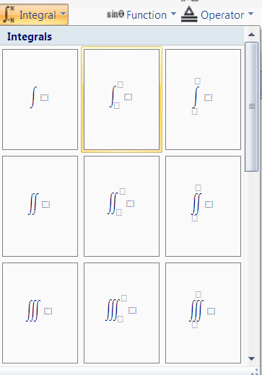
The output is:
$$2$$
Example 5: Evaluate an indefinite double integral.
Input:
$$\int{\left(\int{x}dx\right)}dy$$
Output:
$$y \left(\frac{x^{2}}{2}+С\right)+С$$
Example 6: Consider the following orthonormal set , {$1,\cos{nπ x},\sin{mπx\}, n=1, 2, 3, …, m=1, 2, 3, ….}$ on the interval [-1, 1]. Show using an example within this set that the square norm is one.
Input:
$$integral({(cos{7πx)}}^{2},x,-1,1)$$
The output is:
$$1$$
However by using two functions in this set , $\cos{7πx}$ and $\sin{2πx}$ ,the inner product cannot produce zero with this software.
The input is:
$$integral((cos{7πx)(\sin{2πx),x,-1,1)}}$$
The output is equivalent to the input and does not yield the answer zero.
$$\int_{-1}^{1}{\sin\left(2 π x\right)\cos\left(7 π x\right)ⅆx}$$
Example 7: Evaluate the following line integral using Green’s Theorem by setting up a double integral and assume C consists of the boundary of the region in the first quadrant that is bounded by the graphs of $y=x^{3}$ and $y=x^{4}.$
$$\oint_{C}^{ }{\left(x^{2}-y^{2}\right)dx+\left(2y-x\right)dy}$$
Using Green’s Theorem, you get
$\oint_{C}^{ }{\left(x^{2}-y^{2}\right)dx+\left(2y-x\right)dy}=$ $\int_{0}^{1}{\int_{x^{4}}^{x^{3}}{(-1-\left(-2y\right)dA}}$
To evaluate, the set-up in the input line is:
$$integral\left(integral(\left(-1+2y\right),y,x^{4},x^{3}\right), x, 0, 1)$$
Select Simplify to give the answer:
$$-\frac{23}{1260}$$

Example 8: Graph a helix. An example of the parametric equations for this curve are:
$$x=t, y=\sin{t, z=\cos{t}}$$
This is the graphical user interface (GUI) for the fee based version of Microsoft Math.
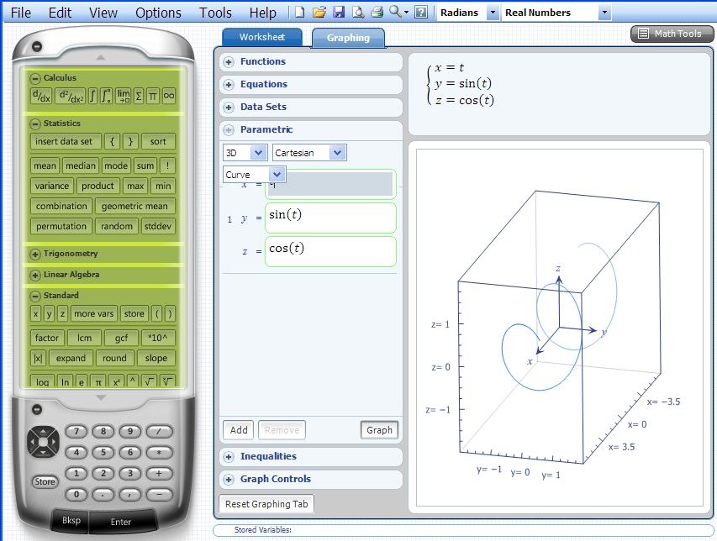
The domain for x, y z, and t are controlled in this next image.
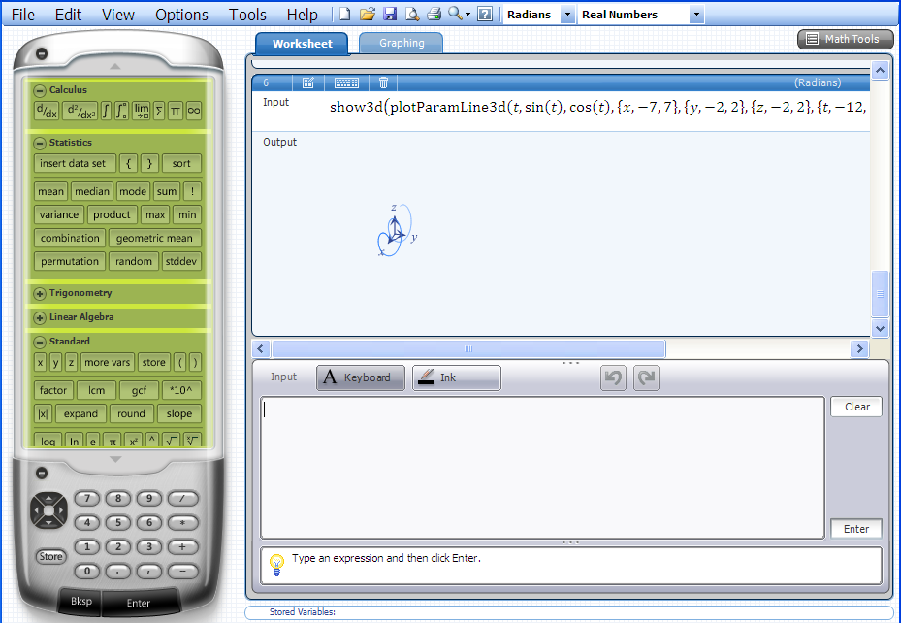
The picture above comes from the fee based version of Microsoft Math, also.
The commands below generate the same images from within the free Word Add-In. Open the math add-in in the usual way and type this command in the pop-up box. Click to highlight the text and then select, Simplify from the options menu.
$$plotParamLine3D(t,\sin{t,\cos{t)}}$$
$$plotParamLine3D(t,\sin{t},\cos{t,\left\{x,-7,7\right\},\left\{y,-2,2\right\},\left\{z,-2,2\right\},\{t,-12,12\})}$$
The domain may be changed by using the last icon on the Display row.
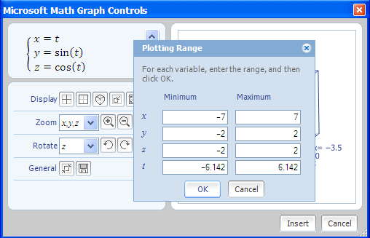
Example 9: Use the show command to plot two different curves/points in two-dimensions.
The show command will plot two different curves/points in two dimensions using one input line. An example is:
$$show\left(plotDataSet\left(\left\{\left\{1 , 5\right\} , \left\{3 , 7\right\} , \left\{- 2 , 0\right\} , \left\{6 , 11\right\}\right\}\right), plotParam(t^{2},t^{3})\right)$$
The output is:
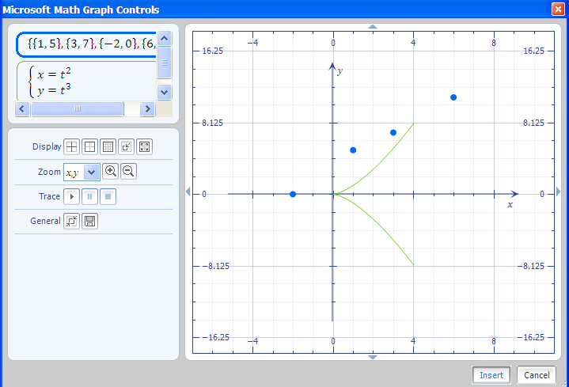
Example 10: Find the limit, if it exists.
$\lim_{\left\{x,y\right\}→\{0,0\}}{\frac{dy}{dx}}$ where $y=\sqrt[3]{x^{3}+y^{3}}$
The problem reduces to evaluating this limit:
$$\lim_{\left\{x,y\right\}→\{0,0\}}{\frac{x^{2}}{{\left(x^{3}+y^{3}\right)}^{\frac{2}{3}}}}$$
Using the limit feature on the ribbon places the problem into a Word text document. However, the problem is not recognized in the math add-in to compute the answer.
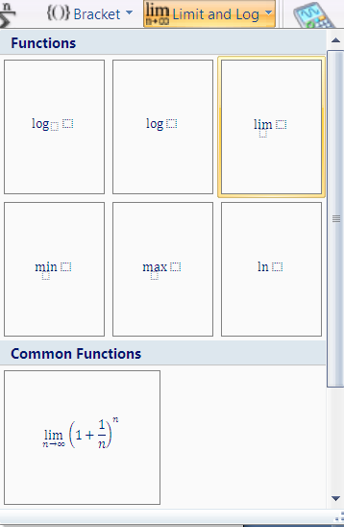
Limit option

Furthermore, the following input line will result with an incorrect answer of zero.
$$limit(deriv\left(\sqrt[3]{x^{3}+y^{3}},x\right),\{x,0\},\{y,0\})$$
$$0$$
The limit does not exist. It is quite easy to find the derivative and cut and paste this into an input line involving a limit.
$$deriv\left(\sqrt[3]{x^{3}+y^{3}},x\right)$$
Here the limit commands are embedded (or nested). In this example, the approach of (0,0) along the x-axis is done where y$→$0. The output is one.
$$limit(limit\left(\frac{x^{2}}{{\left(x^{3}+y^{3}\right)}^{\frac{2}{3}}},y,0\right),x,0)$$
$$1$$
In this input line, the approach of (0,0) along the y-axis is done where x$→$0. The output is zero.
$$limit(limit\left(\frac{x^{2}}{{\left(x^{3}+y^{3}\right)}^{\frac{2}{3}}},x,0\right),y,0)$$
$$0$$
Since the function has two different limits along two different lines, the limit for the original problem does not exist.
If only one variable is involved, the add-in may execute the limit using the limit feature on the ribbon or the limit command.
$$\lim_{x→2}{x^{2}}$$
$$4$$
$$limit(x^{2},x,2)$$
$$4$$
In the above example, the answer appears after selecting Simplify. Similarly this is shown with the example below.
$limit(\frac{\sin\left(ax\right)}{\sin\left(bx\right)},x,0)$
$$\frac{a}{b}$$
$$\lim_{x→0}{\sin\left(ax\right)/sin⁡(bx)}$$
$\frac{a}{b}$
A more complicated limit can be done, also.
$$limit(x^{x},x,0)$$
$1$
Example 11: Find the limit:
$$\lim_{n→∞}{\sum_{k=1}^{n}{1/k^2}}$$
Since only one variable is involved, n, the limit may be possible to find with the math add-in. The limit option on the ribbon and the symbols feature should be used initially. Select the down arrow to bring up more symbols.

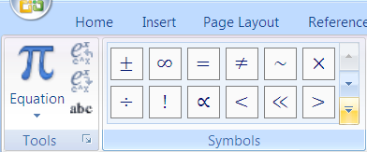
Use down arrow to bring up more symbols.
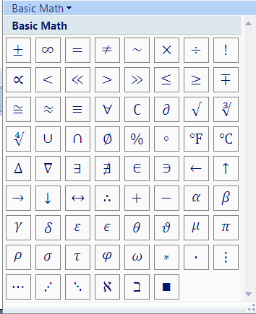
Approach
Infinity
The following is the input and the output for the original example.
$$\lim_{n→∞}{\sum_{k=1}^{n}{1/k^2}}$$
$\frac{π^{2}}{6}$
Example 12: Evaluate an improper integral.
Consider the following input and output:
$$\int_{1}^{∞}{1/x^2}dx$$

In the next similar example, a variable b is introduced.
$$\int_{1}^{b}{1/x^3}dx$$
Right-click and select Simplify from the menu and get:
$$\frac{1}{2}-\frac{1}{2 b^{2}}$$
From this output, make this an equation with introducing the variable y as shown below:
$$\frac{1}{2}-\frac{1}{2 b^{2}}=y$$
Select Plot Both Sides in 2D.
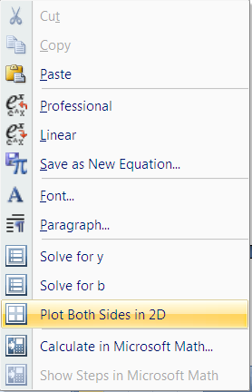
Notice the two graphs of y = x and a vertical line, where the vertical line varies appear. Animate on b and the vertical line moves to the right, as b increases.
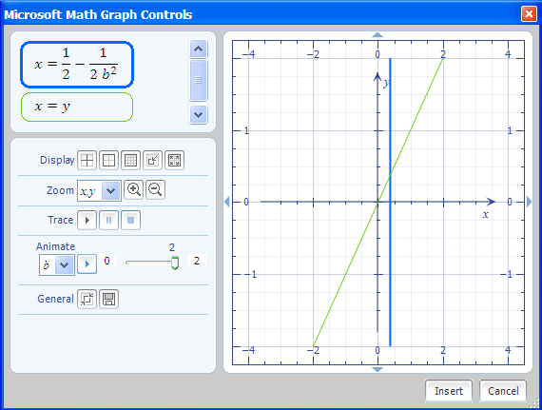
Toggle the right number in the animation from 2 to a larger number. The trace option will allow the estimation of the location of the vertical line after the completion of the animation.
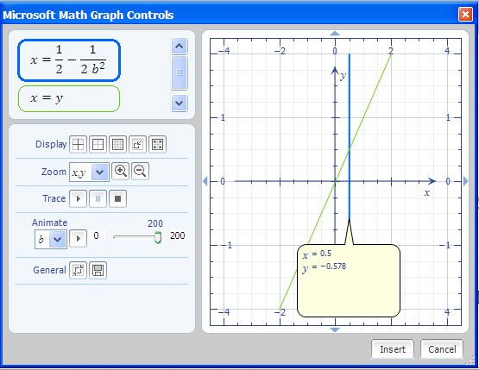
Toggle right number here.
Trace Feature.

References
Thomas, G. and Finney, R. Calculus and Analytic Geometry, 9th edition, Addison-Wesley, Reading, Massachusetts, 1996.
Zill, Dennis G. and Cullen, Michael R. Advanced Engineering Mathematics, 3rd edition, Jones and Bartlett Publishers, Massachusetts, 2006.

Multivariable Calculus
Parametric Curves and Surfaces (Arc Length and Surface Area)

Overview of Needed Information
The command, deriv(input,variable), will take the partial derivative with respect to the variable indicated. The command integral(input, variable, a, b) will evaluate the definite integral from a to b. If the input window toggles from allowing mathematical input, use the Alt key followed with the = key to bring back the mathematical ribbon. Make sure a mathematical input is within the blue window. To input an argument for a trigonometric function, use the trigonometric function followed by the space bar. A blue square will appear for the argument. No parentheses are needed. To finish the argument, place the cursor outside of the blue square.
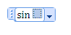

Example 1: Find the length of the asteroid $x={\left(\cos{t}\right)}^{3}$, $y={\left(\sin{t} \right)}^{3}$,$0≤t≤\frac{π}{2}$ (Thomas and Finney, 1996, p. 747).

Answer:
Use the Input:

$${\left(deriv{\left(\cos{t}\right)}^{3},t\right)}^{2}+{\left(deriv{\left(\sin{t}\right)}^{3},t\right)}^{2}$$

Follow this with the commands Simplify and Factor to obtain the following:

$$9{\sin\left(t\right)}^{2}{\cos\left(t\right)}^{4}+9{\cos\left(t\right)}^{2}{\sin\left(t\right)}^{4}$$
$$9{\sin\left(t\right)}^{2}{\cos\left(t\right)}^{2}$$
From the previous output, right click to put the output in a blue box as shown:
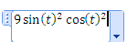
Use the Alt followed with an = to bring the math add-in back. Highlight and press the square root option in the menu ribbon. You will obtain:
$$\sqrt{9{\sin\left(t\right)}^{2}{\cos\left(t\right)}^{2}}$$
The Simplify command will yield:
$$3 \operatorname{abs}\left(\sin\left(t\right)\right) \operatorname{abs}\left(\cos\left(t\right)\right)$$
A math object cannot include paragraph marks or break characters. We will alter the output to the following:
$$3*\sin{t}*\cos{t}$$
Cut and paste the output into a new equation and set up the integral.
$$Integral(3*\sin{t}*\cos{t},t,0,\frac{π}{2})$$
Press Simplify to obtain the result of 3/2.
$$\frac{3}{2}$$
The set-up of the integral from the first output will not yield the result. The Simplify option appears, but does not execute. To use the free add-in, a break-down of the problem requires simplification first.
The input below does not give a result.

$$\int_{0}^{\frac{π}{2}}{\sqrt{9{\sin\left(t\right)}^{2}{\cos\left(t\right)}^{4}+9{\cos\left(t\right)}^{2}{\sin\left(t\right)}^{4}}ⅆt}$$
Example 2: Find the length of the curves where $x={\left(2t+3\right)}^{\frac{3}{2}}/3$, $y=t+t^{2}/2$, $0≤t≤3$ (Thomas and Finney, 1996, p. 749).

Answer:
Use the input:
$${\left(deriv({\left(2t+3\right)}^{1.5}/3,t)\right)}^{2}+ {\left(deriv(t^{1}+t^{2}/2,t)\right)}^{2}$$
Use the options Factor, Expand, and Simplify to obtain the following:
$${\left(t+1\right)}^{2}+2 t+3$$
$$t^{2}+4 t+4$$
$${\left(t+2\right)}^{2}$$
Cut and paste the last input into a new equation window. Highlight and execute the square root option from the ribbon.
$$\sqrt{{\left(t+2\right)}^{2}}$$
The Simplify option gives the answer:
$$\operatorname{abs}\left(t+2\right)$$
Use the result to set-up an integral.
$$integral(t+2,t,0,3)$$
The Simplify command yields the answer 21/2.
$$\frac{21}{2}$$
Again, note that the set-up of the problem using initially an integral symbol is too complicated.
$$\int_{0}^{3}{\sqrt[2]{{\left(deriv({\left(2t+3\right)}^{1.5}/3,t)\right)}^{2}+ {\left(deriv(t^{1}+t^{2}/2,t)\right)}^{2}}} dt$$
Simplify yields a more pleasing looking set-up. Unfortunately, the simplification under the radical is needed before the introduction of an integral command. The output is:
$$\int_{0}^{3}{\sqrt{{\left(t+1\right)}^{2}+2 t+3}ⅆt}$$

Example 3: Find the surface area generated by revolving the curve about the y-axis. The curve is $x=\frac{2}{3}t^{\frac{3}{2}}$ , $y=2\sqrt[2]{t}$, $0≤t≤\sqrt[2]{3}$ (Thomas and Finney, 1996, p. 749).

Answer:
Consider:
$${\left(deriv(2t^{1.5}/3,t)\right)}^{2}+ {\left(deriv(2\sqrt{t},t)\right)}^{2}$$
Simplify and Factor gives the outputs:
$$t+\frac{1}{t}$$
$$\frac{t^{2}+1}{t}$$
Cut and paste the previous output and multiply by x.
$$\frac{2 \sqrt{\frac{t^{2}+1}{t}} ×t^{\frac{3}{2}}}{3}$$
Unfortunately, the output is not simplified.
$$\frac{2 \sqrt{\frac{t^{2}+1}{t}} t^{\frac{3}{2}}}{3}$$
Some college algebra by the students will consider the input:
$$\frac{2 \sqrt{\frac{t^{2}+1}{1}} t^{1}}{3}$$
The integral will be evaluated after pressing Simplify. Note that the u substitution is done to give the surface area as 14/9.
$integral(\frac{2 \sqrt{\frac{t^{2}+1}{1}} t^{1}}{3},t,0,\sqrt[2]{3}$)

$$\frac{14}{9}$$
The math add-in would have considered an indefinite integral. Consider the following as an input:
$$\frac{2 \sqrt{\frac{t^{2}+1}{1}} t^{1}}{3}$$
The option of Integrate on t appears from the drop-down menu to give the answer using a u substitution of:

$$\frac{2 {\left(t^{2}+1\right)}^{\frac{3}{2}}}{9}+С$$
Reference
Thomas, G. and Finney, R. Calculus and Analytic Geometry, 9th edition, Addison-Wesley, Reading, Massachusetts, 1996.

