THE HOUSE OFTHE VETTII

THE OWNERS The house of the Vettii was owned by two wealthy brothers - Aulus Vettius Conviva and Aulus Vettius Restitutus. These two brothers were merchants who restored their house after the earthquake of 62 A.D. The house is a very good example of a property owned by the commercial middle class as opposed to the aristocracy of Pompeii.
The House of the Faun and the Villa of the Mysteries was owned by the aristocracy of Pompeii where as The House of the Vettii was owned by commercial middle class.
Commercial middle class: People who have made money through commercial ventures but do not have social influence or power.
Aristocracy: Those Pompians who have political power and wealth, probably with hereditary titles. The Vetti brothers would have wanted to be part of this class but because of their background as slaves they would never have succeded. You would have had to been born into this privlidged set.
The Vetti brothers used to be slaves, they made enough money to buy their own freedom. After buying their freedom they worked as merchants, meaning they sold goods which they themselves didn’t produce.
As freedmen the Vetti brothers would not have had the same social standing as aristocracy in Pompeii. The Vetti brothers would have been what we call today ‘social climbers’ and would have been eager to show off their wealth, this is evident in their house which is filled with exciting rooms and artwork
- How do we know that Villa of the Mysteries was owned by the aristocracy or elite of Pompeii?
- Can you think of any famous people or persons in modern day Britain who would be referred to as:
- Aristocracy
- Middle Class

UNUSAL FEATURES and LAYOUT
There were no shops at the front of this house unlike other houses in Pompeii and so there is no evidence of the commercial interests of the brothers.
The house has two atria or halls and a garden .
Unusually the house has no tablinum or study.
The main rooms in the house are based around the first main atrium and the peristyle.
The slaves quarters are generally found around the smaller, second atrium which also contained the stairs to the upper floor.
See the city layout to find where the House of the Vettii is located in Pompeii.
- Explain two ways in which the design of the house of the Vettii differs from a traditional Pompeian house (domus)

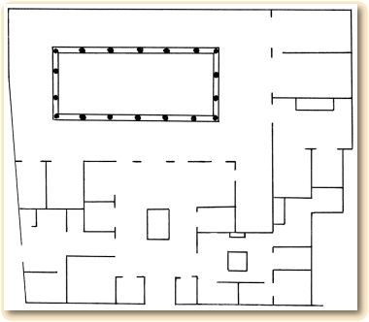

ROOMS OF INTERST and DECORATION
In Greek mythology, Priapus was a minor rustic fertility god, protector of livestock, fruit plants, gardens and male genitalia. His Roman equivalent was Mutinus Mutunus. He was best noted for his huge, permanently erect penis.
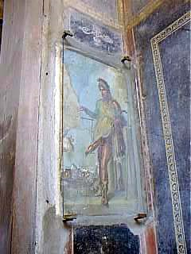

In the entrance hall to the house is a painting of a Priapus who is weighing his phallus on some scales. Although this appears rather strange today, this was a common feature of Pompeian houses. Not only did this image symbolise fertility, it also kept bad luck away from the house.

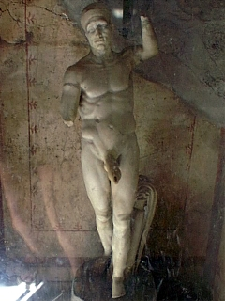
This statue of Priapus is from a small cubicle leading off from the kitchen, one of the service rooms of the house. He has a large phallus with a hole running through it as can be seen in the picture. This indicates that the statue was most probably originally in the garden of the House of the Vettii and was used as a fountain. Also found in this room were erotic paintings.
- Make notes in your book on Priapus
  - Who was he?
  - How was he represented in the house
  - Why do you think the Vetti brothers had images of him in their house

Many of the images that decorate the walls of the house of the Vettii have two distinct themes
- Images of love between mortals and the gods
- Images depicting Theban Mythology.
- Read the following descriptions and familiarise yourself with the myths by making brief story outline in your books.

THEBAN MYTHOLOGY
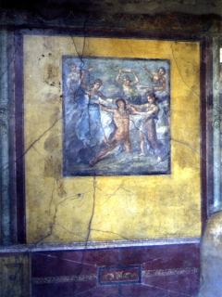
The reception room overlooked the garden of the House of the Vettii. It is decorated with a number of wall paintings in the Fourth Style depicting Theban mythology.
Fouth style: featured representations of opened doors and windows. These images, crowded with architectural elements, created an illusion of depth and perspective. It is characterized by painted "windows" in which the viewer could see a variety of framed fantasy scenes. The viewer does not look out on cityscapes but on fragments of buildings or scenes from Greek myths, giving windows to windowless rooms
This picture above is from the back wall of the reception room and shows Pentheus being torn to pieces.
Pentheus opposed the cult of Bacchus in his city of Thebes and so was torn to pieces by women in a Bacchic frenzy who were involved in this cult. Pentheus' mother was one of the women responsible for tearing her son to pieces. However, in her madness and frenzy she did not recognise her own son. The picture shows two women pulling at Pentheus' hair with other women preparing to attack him. Pentheus himself is kneeling on his left knee and trying to escape from these frenzied women.
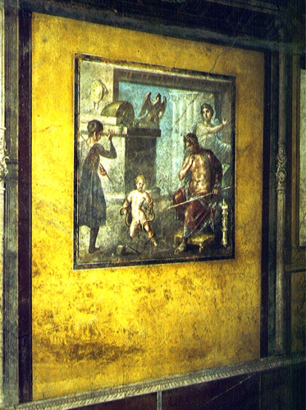
This picture is from the left hand wall of the reception room and shows Hercules killing a serpent.
Hercules was the son of Jupiter (Zeus) and Alcmena and was born in Thebes. Juno, Jupiter's wife was jealous of this child , she wanted her son to be greater than Hercules and so she put serpents into Hercules' cradle. However, Hercules succeeded in overpowering these serpents. This picture shows Hercules wrestling and strangling the snakes.

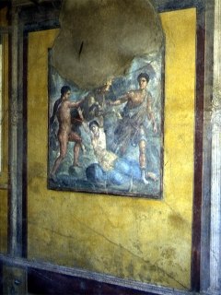
This picture is from the right hand wall of the reception room and shows Dirce tied to a bull.
The two young men who are tying her to the bull are Amphion and Zethus, who were the sons of Antiope by Jupiter. Antiope had been freed by Jupiter after she had been imprisoned by her husband Lycus. Lycus had done this in order to marry Dirce, queen of Thebes. So, in order to vindicate their mother, Amphion and Zethus tied Dirce to the bull, which eventually drowned her in a spring.
LOVE BETWEEN MORTALS and GODS
The reception room overlooking the garden is decorated with images from Greek mythology, the myths seem to be linked by a similar theme. The myths deal with love between the gods and the mortals.
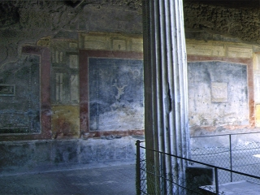
This picture depicts the suffering of Ixion.
Ixion had tried to win the love of Hera, Zeus' wife. In order to stop this, Zeus formed a cloud, Nephele, to resemble Hera. Ixion made love to the cloud thinking it was Hera. From this union Ixion became the father of the centaur
As a punishment for his crime, Zeus sent him to the underworld where he was punished by being fixed to a wheel that turned forever.
Other images of Ariadne abandoned and a picture of Pasiphae and her passion with the bull.
Minos attacked Athens after his son was killed there. The Athenians asked for terms, and were required to sacrifice seven young men and seven maidens every nine years to the Minotaur. One year, the sacrificial party included Theseus, a young man who volunteered to come and kill the Minotaur. Ariadne fell in love at the first sight of him, and helped him by giving him a sword and a ball of the red fleece thread she was spinning, so that he could find his way out of the Minotaur's labyrinth. Theseus abandoned Ariadne sleeping on Naxos, and Dionysus rediscovered and wedded her

PASIPHAE was an immortal daughter of the sun-god Helios. Pasiphae wed King Minos of Krete, and bore him a number of sons and daughters. However, as punishment for some offence against the gods committed either by herself or her husband, she was cursed with the desire to be coupled with the king's finest bull. The Queen conscripted the great artisan Daidalos to assist her in the endeavour, and he built for her a hollow wooden cow, wrapped in a bovine skin and endowed with mechanical life. Hiding herself inside this contraption she conceived and bore a hybrid child, the bull-headed Minotauros. Pasiphae's husband Minos also proved unfaithful. When the Queen learned of his indiscretions she cast a spell on him which caused him to ejaculate poisoned creatures and so destroy his lovers. Pasiphae herself, being an immortal, was alone immune. Minos was eventually cured by the Athenian girl Prokris who devised a remedy for his strange afflication.

DECORATIONS and ROOMS OF INTEREST
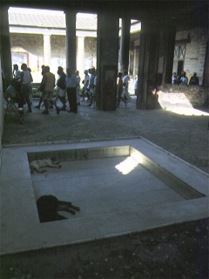
In the atrium there was a large 'impluvium' to collect rainwater. This pool can be seen in the picture. In the early days of Pompeii, before it had a proper water supply, the water collected in the impluvium was of great importance to a household. Above this impluvium there is the 'compluvium' or opening in the roof to let light and rain in. This compluvium still has the original terracotta water spouts through which the rain ran down into the impluvium below.

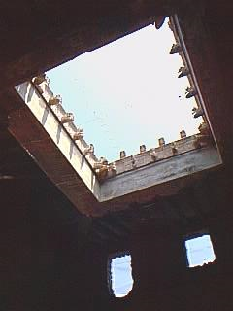
This picture shows the compluvium from the House of the Vettii. A compluvium was an opening in the roof. The rain water ran down the roof to this opening where it then ran through terracotta water spouts in the shape of animals. The water spouts can be seen in this picture. This water was collected in a rectagular basin called an impluvium which was placed directly underneath the compluvium. The compluvium also let light into the atrium which otherwise had no or very few windows.

- In your books write down the definition of:
Compluvuium
Impluvium

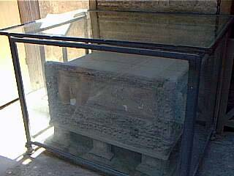
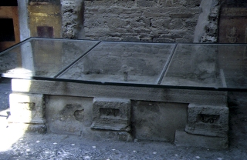
Two strongboxes were found in one of the main atrium of the house. There would have been locked and keep treasures and valuables owned by the Vettii brothers.

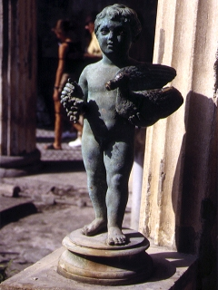
The bronze fountain is a small statue of a cupid holding a goose in his arms. There would have been a jet of water coming out of the goose's mouth. Fountains such as this were supplied with water through lead pipes (fistulae). The aqueduct which supplied Pompeii with water enabled wealthy home owners like the Vettii to have water fountains in their gardens.

- What can these three objects found in the house of Vettii tell us about the occupants of the house?
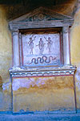
This is a lararium or a household shrine dedicated to the gods of the house called lares. Shrines were common in the atrium of a Roman house. This lararium is in the second atrium of the House of the Vettii
The central figure which you can see in the painting on the shrine is the spirit of the house or 'genius'. Two lares surround this 'genius' and each one holds a horn for drinking and a small bucket. Underneath you can see a snake.

- Give three details of an impressive piece of decoration that can be found in the house.

House of the Vettii revision

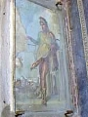 | - What was the purpose of this picture in the entrance way of the house?  It gave waiting guests something to look at  It kept bad luck away from the house  It kept unwanted guests from the house  It hid a safe in the wall
- Which important room does the House of the Vetti not have?
Tablinum
Kitchen
Triclinium
Cubiculum
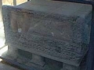 | - In which room would you find this object?  Kitchen/culina  Garden  Atrium  Triclinium
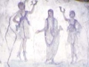 | - What are shown on this lararium?  2 lares and a genius  2 genii and a lar  2 dancers and a girl  2 genii and a girl
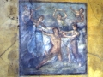 | - Who is depicted in the centre of this painting?  Hercules  Pentheus  Ixion

